

Combined 2020 and 2021 Air Quality Annual Status Report (ASR)

In fulfilment of Part IV of the Environment Act 1995 Local Air Quality Management

Date: December, 2021

|  |  |
| --- | --- |
| Information | East Hampshire District Council Details |
| **Local Authority Officer** | David Fitzgerald |
| **Department** | Environmental Health |
| **Address** | East Hampshire District Council,  Penns Place, Petersfield,  GU31 4EX |
| **Telephone** | 01730 234323 |
| **E-mail** | ehealth@easthants.gov.uk |
| **Report Reference Number** | EHDC 2019 and 2020 ASR |
| **Date** | December 2021 |

# Executive Summary: Air Quality in Our Area

## Air Quality in East Hampshire District Council

Air pollution is associated with a number of adverse health impacts. It is recognised as a contributing factor in the onset of heart disease and cancer. Additionally, air pollution particularly affects the most vulnerable in society: children, the elderly, and those with existing heart and lung conditions. There is also often a strong correlation with equalities issues because areas with poor air quality are also often less affluent areas[1],[2].

The mortality burden of air pollution within the UK is equivalent to 28,000 to 36,000 deaths at typical ages[3], with a total estimated healthcare cost to the NHS and social care of £157 million in 2017[4].

Air quality within the East Hampshire District is generally good. The latest monitoring data from 2019 and 2020 shows compliance with the nitrogen dioxide (NO2) air quality objectives has been achieved. The air quality objectives for all other pollutants, but particularly those for sulphur dioxide (SO2) and particulates (PM10), are likely to be achieved throughout East Hampshire. As a result of this no need has been identified to declare an Air Quality Management Area (AQMA) for any pollutants.

Despite compliance with the objective in 2019 and 2020 NO2, whose main source is road transportation, continues to be the only pollutant that has shown elevated concentrations in East Hampshire. As a result, emphasis has been placed on consideration of this pollutant within the main body of the ASR. There is a general decreasing trend in annual mean NO2 concentrations over the past five years. There was a significant reduction between 2019 and 2020, though this is in large part likely to be the result of the COVID-19 pandemic and associated travel restrictions.

## Actions to Improve Air Quality

Whilst air quality has improved significantly in recent decades, and is expected to continue to improve due to national policy decisions, there are some areas where local action is needed to improve air quality further.

The 2019 Clean Air Strategy[5] sets out the case for action, with goals even more ambitious than EU requirements to reduce exposure to harmful pollutants. The Road to Zero[6] sets out the approach to reduce exhaust emissions from road transport through a number of mechanisms; this is extremely important given that the majority of AQMAs are designated due to elevated concentrations heavily influenced by transport emissions.

The Council continues to regularly review potential sources and to monitor air quality across the district for this purpose. East Hampshire District Council declared a climate emergency in July 2019 and adopted a Climate and Environment Strategy in August 2020[7]. As well as seeking to establish energy security through sustainable means, the Strategy sets out to reduce pollution through the objectives and initiatives outlined in Figure 1.

Figure : Climate Emergency Objectives and Initiatives

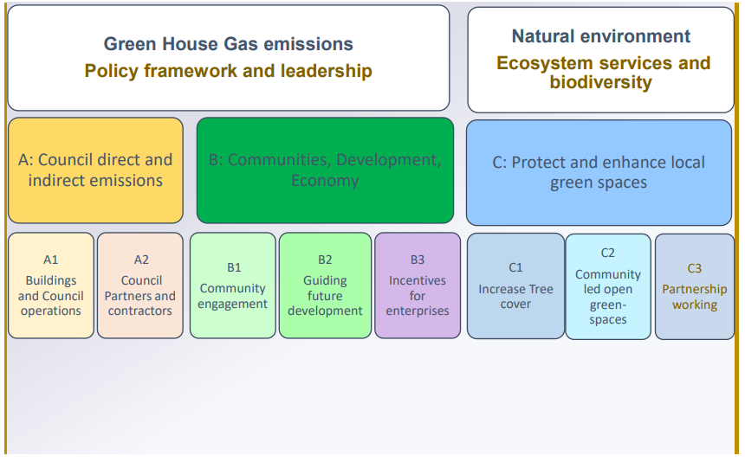

A number of projects have been initiated that have direct benefit to air quality including:

* Installation of an electric vehicle charging network;
* Procurement of electric fleet vehicles;
* The Council working towards becoming a green energy supplier;
* Working with the Local Strategic Partnerships to reduce car usage;
* Whitehill & Bordon’s Green, Healthy and Connected programme, including its domestic energy retrofit programme; and
* District Wide “Enhance East Hants” which promotes low carbon and cycling.

Complementing this work, the ‘Vehicle Parking Standards’ Supplementary Planning Document (SPD) was revised and adopted in July 2018 and encourages the provision of electric vehicle charge points in new developments in most parts of the Council area. In addition, the emerging Local Plan fosters implementation of EV charge-points in new developments.

The Whitehill & Bordon regeneration project has developed the Green, Healthy and Connected programme to deliver a self-sufficient and sustainable local community. This includes the development of a network of footpaths and cycle ways known as the Green Loop to encourage walking and cycling and reduce reliance on cars. The Whitehill & Bordon regeneration project will provide electric vehicle charging point.

The Bordon Relief Road was completed and opened in January 2019. This road diverts traffic away from the Bordon town centre, which has historically demonstrated the highest levels of pollution within the District Council and was close to breaching the air quality objective limits. The Regeneration and Place-Making team is working with Hampshire County Council to improve the current bus provision to the neighbouring towns.

## Conclusions and Priorities

NO2 is the primary pollutant of concern but does not exceed air quality objectives, therefore no AQMA has been declared. Monitoring of NO2 will continue to ensure this remains the case. No new or alternative locations will be monitored as there are no changes to the sources and local knowledge does not suggest the need for further monitoring beyond the two sites relocated in 2020.

The priorities for the coming year are described below.

* Re-focus officer time on air quality post COVID-19 pandemic;
* The Energy Strategy will continue to be a key local priority. It has potential to reduce carbon emissions, reduce local pollution, and improve housing stock (through insulation schemes and replacement of energy consuming systems with more efficient ones). There are direct public health benefits in the reduction of pollution and improving ambient temperatures in the housing stock as well as addressing energy poverty;
* The Cycling and Walking Strategy (formerly the Active Transport Strategy) is being updated with a view to promoting these forms of transport. Further actions are likely once this has been published; and
* The Whitehill & Bordon regeneration project remains a key corporate priority. The intention is to deliver some 3,500 new homes as well as take action to improve the existing housing stock. This is a 20-year project with final delivery due in 2036. It should deliver significant economic and environmental benefits.

## Local Engagement and How to get Involved

Road traffic gives rise to much of the air pollution in the East Hampshire district. There are a range of ways for people to get involved and help tackle this.

Businesses can:

* set up workplace travel plans and more information is available here: <http://www3.hants.gov.uk/workplacetravel>; and
* subscribe to scheme such as Easit to obtain discount on travel and electric vehicles: <https://www.easit.org.uk/>

Everyone can:

* Walk, cycle, car share or use public transport. For information about journey planning visit <http://myjourneyhampshire.com/>;
* Switch to low emission vehicles. Grants are still available: https://www.gov.uk/plug-in-car-van-grants/what-youll-get. Further information and advice on electric vehicles and charging locations is available here: <https://www.zap-map.com/>; and
* Insulate buildings and wherever possible use electric heating system or low NOx emitting boilers to reduce background pollution levels.

Table of Contents

Executive Summary: Air Quality in Our Area i

Air Quality in East Hampshire District Council i

Actions to Improve Air Quality ii

Conclusions and Priorities iii

Local Engagement and How to get Involved iv

1 Local Air Quality Management 1

2 Actions to Improve Air Quality 2

Air Quality Management Areas 2

Progress and Impact of Measures to address Air Quality in East Hampshire District Council 3

PM2.5 – Local Authority Approach to Reducing Emissions and/or Concentrations 6

3 Air Quality Monitoring Data and Comparison with Air Quality Objectives and National Compliance 7

Summary of Monitoring Undertaken 7

3.1.1 Automatic Monitoring Sites 7

3.1.2 Non-Automatic Monitoring Sites 7

Individual Pollutants 7

3.1.3 Nitrogen Dioxide (NO2) 8

Appendix A: Monitoring Results 9

Appendix B: Full Monthly Diffusion Tube Results 15

Appendix C: Supporting Technical Information / Air Quality Monitoring Data QA/QC 17

New or Changed Sources Identified Within East Hampshire District Council During 2019 and 2020 17

Additional Air Quality Works Undertaken by East Hampshire District Council During 2019 and 2020 17

QA/QC of Diffusion Tube Monitoring 17

Diffusion Tube Annualisation 18

Diffusion Tube Bias Adjustment Factors 18

NO2 Fall-off with Distance from the Road 19

Appendix D: Map(s) of Monitoring Locations and AQMAs 21

Appendix E: Summary of Air Quality Objectives in England 27

Appendix F: Impact of COVID-19 upon LAQM 28

Impacts of COVID-19 on Air Quality within East Hampshire District Council 29

Opportunities Presented by COVID-19 upon LAQM within East Hampshire District Council 29

Challenges and Constraints Imposed by COVID-19 upon LAQM within East Hampshire District Council 29

Glossary of Terms 32

References 33

Figures

Figure A.1 – Trends in Annual Mean NO2 Concentrations at Bordon Monitoring Sites 13

Figure A.2 – Trends in Annual Mean NO2 Concentrations at Other East Hampshire District Council Monitoring Sites 14

Figure D.1 – Map of Non-Automatic Monitoring Sites in Bordon 21

Figure D.2 – Map of Non-Automatic Monitoring Sites in Whitehill 22

Figure D.3 – Map of Non-Automatic Monitoring Sites in Alton 23

Figure D.4 – Map of Non-Automatic Monitoring Sites in Four Marks 24

Figure D.5 – Map of Non-Automatic Monitoring Sites in Petersfield 25

Figure D.6 – Map of Non-Automatic Monitoring Sites in Horndean 26

Tables

Table 2.1 – Progress on Measures to Improve Air Quality 5

Table A.1 – Details of Non-Automatic Monitoring Sites 9

Table A.2 – Annual Mean NO2 Monitoring Results: Non-Automatic Monitoring (µg/m3) 11

Table B.1 – NO2 2019 Diffusion Tube Results (µg/m3) 15

Table B.2 – NO2 2020 Diffusion Tube Results (µg/m3) 16

Table C.1 – Bias Adjustment Factor 18

Table C.2 – 2020 Annualisation Summary (concentrations presented in µg/m3) 20

Table E.1 – Air Quality Objectives in England 27

Table F 1 – Impact Matrix 31

# Local Air Quality Management

This report provides an overview of air quality in East Hampshire District Council during 2019 and 2020. It fulfils the requirements of Local Air Quality Management (LAQM) as set out in Part IV of the Environment Act (1995) and the relevant Policy and Technical Guidance documents.

The LAQM process places an obligation on all local authorities to regularly review and assess air quality in their areas, and to determine whether or not the air quality objectives are likely to be achieved. Where an exceedance is considered likely the local authority must declare an Air Quality Management Area (AQMA) and prepare an Air Quality Action Plan (AQAP) setting out the measures it intends to put in place in pursuit of the objectives. This Annual Status Report (ASR) is an annual requirement showing the strategies employed by East Hampshire District Council to improve air quality and any progress that has been made.

The statutory air quality objectives applicable to LAQM in England are presented in Table E.1.

# Actions to Improve Air Quality

## Air Quality Management Areas

Air Quality Management Areas (AQMAs) are declared when there is an exceedance or likely exceedance of an air quality objective. After declaration, the authority should prepare an Air Quality Action Plan (AQAP) within 12 months setting out measures it intends to put in place in pursuit of compliance with the objectives.

East Hampshire District Council currently does not have any declared AQMAs. LAQM TG16 recommends that authorities should consider declaring and AQMA in areas identified as having a risk of exceeding an air quality objective. Monitoring locations BR4, BR5 and BR7 in Bordon, and HR1 in Horndean have previously shown concentrations within 10% of the annual mean NO2 air quality objective in the past 5 years. However, concentrations have remained well below this threshold in these locations during 2019 and 2020. It is anticipated that NO2 concentrations will stabilise or reduce with the Whitehill & Bordon regeneration and initiatives including the new relief road and the generation of the green grid to facilitate active travel techniques. As such, whilst East Hampshire District Council will continue to monitor concentrations closely, is not considering declaring any AQMAs at this stage.

## Progress and Impact of Measures to address Air Quality in East Hampshire District Council

Defra’s appraisal of the previous ASR concluded the report is detailed, concise and satisfies the criteria of relevant standards. The main comments received are outlined below, with a response detailed in italics:

1. The report provides a discussion on the measures the Council are implementing to improve air quality in the borough, despite this not being a requirement as there are no AQMAs present. The inclusion of this discussion demonstrates the Council’s active engagement to improving air quality and is a sign of good practice. *Noted.*
2. It would be useful if Section 2.3 could make reference to the Public Health Outcomes Framework, and the local indicator for PM2.5 in the district. The Council may wish to consider comparing the ‘3.01 - Fraction of mortality attributable to particulate air pollution indicator’ value for East Hampshire to nearby LAs and National indicator values. This can be found in the link below. <https://fingertips.phe.org.uk/profile/public-health-outcomesframework/data#page/0/gid/1000043/pat/6/par/E12000005/ati/101/-are/E07000194>. *A reference to the Public Health Outcomes Framework, and indicator D01 (previously 3.01) has been included.*
3. The Council have provided distance corrected values though not incorrect, it is not required for the Council to perform a distance correction as no NO2 concentrations were above the AQOs. If the Council wish to distance correct it would be beneficial for them to include their distance correction calculations. The Council can use and present the distance correction calculator provided by Defra. <https://laqm.defra.gov.uk/tools-monitoring-data/no2-falloff.html>. *Distance correction has only been performed where required (no applicable at any locations in 2019 and 2020).*

East Hampshire District Council has taken forward a number of direct measures during the current reporting years of 2019 and 2020 in pursuit of improving local air quality. Details of all measures completed, in progress or planned are set out in Table 2.1. 11 measures are included within Table 2.1, with the type of measure and the progress East Hampshire District Council have made during the reporting year of 2019 and 2020 presented. Where there have been, or continue to be, barriers restricting the implementation of the measure, these are also presented within Table 2.1.

Key completed measures are:

* The opening of the Bordon Relief Road in January 2019. This has been diverting traffic away from the town centre;
* The purchase of Nissan Leaf and NV 200 vehicles by East Hampshire District Council to prioritise uptake of low emission vehicles;
* The installation of 10 new electric vehicle charging bays across the district; and
* The Shipwrights Way, opened in July 2016, is a 50-mile long distance path for walkers, cyclists and horse-riders, linking the towns and villages of East Hampshire.

East Hampshire District Council’s priorities for the coming year are to continue the implementation of the Climate and Environment Strategy, Modeshift STARS school travel plans, workplace travel plans, and bike-ability training to promote travel alternatives.

East Hampshire District Council anticipates that the measures stated above and in Table 2.1 will ensure NO2 concentrations remain below the AQO across the District, and that the declaration of an AQMA will not be required.

Table 2.1 – Progress on Measures to Improve Air Quality

| Measure No. | Measure | Category | Classification | Year Measure Introduced | Estimated / Actual Completion Year | Organisations Involved | Funding Source | Defra AQ Grant Funding | Funding Status | Estimated Cost of Measure | Measure Status | Reduction in Pollutant / Emission from Measure | Key Performance Indicator | Progress to Date | Comments / Barriers to Implementation |
| --- | --- | --- | --- | --- | --- | --- | --- | --- | --- | --- | --- | --- | --- | --- | --- |
| 1 | Council Low Emission Fleet | Promoting Low Emission Transport | Company Vehicle Procurement - Prioritising uptake of low emission vehicles | - | 2017 | East Hampshire District Council | - | - | - | - | Completed | N/A | Purchase of Nissan Leaf and NV 200 completed | Vehicles purchased March 2017 | - |
| 2 | Electric Charge Point Network | Promoting Low Emission Transport | Other | - | 2018 | East Hampshire District Council | - | - | - | - | Completed | N/A | Installation of 8 charging points | 10 charge bays installed | Ten installed by Council and others available locally |
| 3 | Modeshift STARS | Promoting Travel Alternatives | School Travel Plans | - | - | Hampshire County Council & East Hampshire District Council | - | - | - | - | Implementation | N/A | Number of schools participating | 8 bronze achieved and 1 silver | - |
| 4 | Park and Stride | Traffic Management | Other | 2016 | - | East Hampshire District Council | - | - | - | - | Implementation | N/A | - | Advertised on web and scheme in place | School drop off to nearby car park and then walk remainder |
| 5 | Work travel plans | Promoting Travel Alternatives | Workplace Travel Planning | 2011 | - | Hampshire County Council | - | - | - | - | Implementation | N/A | - | Information published on internet and support available | Sustrans provide implementation for Hampshire County Council |
| 6 | Shipwrights Way | Transport Planning and Infrastructure | Cycle Network | 2016 | 2016 | Hampshire County Council | - | - | - | - | Completed | N/A | Opening of 50 mile cycle route | Completed July 2016 | - |
| 7 | High speed broadband coverage | Promoting Travel Alternatives | Encourage / Facilitate home-working | 2011 | 2018 | Hampshire County Council | - | - | - | - | Completed | N/A | - | Phase 1 (94% coverage) completed to July 2018 | Objective 11, Hants Transport Plan 2011-2031 |
| 8 | "My Journey - Helping Hampshire Getting Around" Travel Awareness Campaign | Promoting Travel Alternatives | Intensive active travel campaign & infrastructure | 2011 | - | Hampshire County Council | - | - | - | - | Implementation | N/A | - | Website established | Includes travel planning and car sharing |
| 9 | Bikeability training | Promoting Travel Alternatives | Intensive active travel campaign & infrastructure | 2011 | - | Hampshire County Council | - | - | - | - | Implementation | N/A | - | Advertised on web and scheme in place | - |
| 10 | Licensing requirement for taxis | Promoting Low Emission Transport | Taxi Licensing conditions | - | - | East Hampshire District Council | - | - | - | - | Implementation | N/A | - | Vehicles over six years old are required to have MOT every six months | - |
| 11 | Cleaner buses | Promoting Low Emission Transport | Public Vehicle Procurement - Prioritising uptake of low emission vehicles | - | - | Hampshire County Council | - | - | - | - | Implementation | N/A | Percentage of fleet complying with Euro V standard | Stagecoach has 70% of fleet Euro V and has plans to replace 6 older buses during 2016 | - |

## PM2.5 – Local Authority Approach to Reducing Emissions and/or Concentrations

As detailed in Policy Guidance LAQM.PG16 (Chapter 7), local authorities are expected to work towards reducing emissions and/or concentrations of PM2.5 (particulate matter with an aerodynamic diameter of 2.5µm or less). There is clear evidence that PM2.5 has a significant impact on human health, including premature mortality, allergic reactions, and cardiovascular diseases.

The Public Health Outcomes Framework (see https://fingertips.phe.org.uk/profile/public-health-outcomes-framework) provides an estimate of the impact of particulate pollution on human health. Indicator D01 – Fraction of mortality attributable to particulate air pollution is the mortality burden associated with long-term exposure to PM2.5 as a percentage of the annual deaths from all causes in those aged 30+. The fraction of mortality attributable to particulate pollution in East Hampshire was 4.4% in 2019. This is lower than the regional (South East England) value of 5.2% and national value of 5.1%.

East Hampshire District Council is taking the following measures to address PM2.5:

Although there are no specific measures targeting the reduction of PM2.5 currently, it is expected that the combination of actions and that are currently in force or coming into force will help to bring about a reduction of PM2.5. However, discussions are being held with Public Health to devise policies that will specifically target the reduction of PM2.5.

# Air Quality Monitoring Data and Comparison with Air Quality Objectives and National Compliance

This section sets out the monitoring undertaken within 2019 and 2020 by East Hampshire District Council and how it compares with the relevant air quality objectives. In addition, monitoring results are presented for a five-year period between 2016 and 2020 to allow monitoring trends to be identified and discussed.

## Summary of Monitoring Undertaken

### Automatic Monitoring Sites

East Hampshire District Council ceased automatic (continuous) monitoring during 2017 due to an equipment breakdown. This has not been replaced, and therefore no automatic monitoring data is presented in this report.

### Non-Automatic Monitoring Sites

East Hampshire District Council undertook non- automatic (i.e. passive) monitoring of NO2 at 12 sites during 2019 and 2020, with two duplicate locations (BR4 and BR7, and BR5 and BR8. Results are reported separately for these sites as the monitoring is undertaken at different heights). Two monitoring locations (BR3 and BR6) were decommissioned at the end of 2019, with two monitoring locations introduced in 2020 (FR1 and FR2). In 2020, two sites (BR7 and BR8) had insufficient data capture to report an annual mean concentration. Table A.1 in Appendix A presents the details of the non-automatic sites.

Maps showing the location of the monitoring sites are provided in Appendix D. Further details on Quality Assurance/Quality Control (QA/QC) for the diffusion tubes, including bias adjustments and any other adjustments applied (e.g. annualisation and/or distance correction), are included in Appendix C.

## Individual Pollutants

The air quality monitoring results presented in this section are, where relevant, adjusted for bias, annualisation (where the annual mean data capture is below 75% and greater than 25%), and distance correction. Further details on adjustments are provided in Appendix C.

### Nitrogen Dioxide (NO2)

Table A.2 in Appendix A compares the ratified and adjusted monitored NO2 annual mean concentrations for the past five years with the air quality objective of 40µg/m3. Note that the concentration data presented represents the concentration at the location of the monitoring site, following the application of bias adjustment and annualisation, as required (i.e. the values are exclusive of any consideration to fall-off with distance adjustment).

For diffusion tubes, the full 2019 and 2020 dataset of monthly mean values is provided in Appendix B.

There were no exceedances of the annual mean NO2 objective at any monitoring location within East Hampshire during 2019 or 2020. The highest annual mean NO2 concentration was recorded at monitoring location HR1 in 2019, measuring 32.9 µg/m3. In 2020, the maximum concentration was 23.5 µg/m3 recorded at BR4. Both monitoring locations are roadside sites.

Figures A.1 and A.2 present the trends in annual mean NO2 concentrations as East Hampshire monitoring locations since 2014. The majority of monitoring locations show an overall slight decreasing trend in annual mean NO2 concentrations since 2014, albeit with some fluctuations.

Between 2018 and 2019, only HR7 showed an increase (of 0.2 µg/m3), with all other locations showing a decrease in annual mean NO2 concentrations. The town centre of Bordon has historically seen the highest concentrations within the District, with BR4, BR5 and BR7 measuring concentrations within 10% of the annual mean NO2 air quality objective in preceding years. Monitoring locations within Bordon showed the largest reductions between 2018 and 2019 (BR4 and BR7 decreased by 6.1 and 5.3 µg/m3 respectively). This is potentially the impact of the openning of the Bordon Relief Road in June 2019, which has helped divert traffic away from Bordon town centre.

Between 2019 and 2020, there was a widespread reduction in annual mean NO2 concentrations, with decreases ranging from 2.4 to 10.2 µg/m3. This notable reduction in annual mean NO2 concentrations is likely to be associated with the impact on traffic flows arising from the COVID-19 pandemic restrictions.

# Appendix A: Monitoring Results

Table A.1 – Details of Non-Automatic Monitoring Sites

| Diffusion Tube ID | Site Name | Site Type | X OS Grid Ref (Easting) | Y OS Grid Ref (Northing) | Pollutants Monitored | In AQMA? Which AQMA? | Distance to Relevant Exposure (m) (1) | Distance to kerb of nearest road (m) (2) | Tube Co-located with a Continuous Analyser? | Tube Height (m) |
| --- | --- | --- | --- | --- | --- | --- | --- | --- | --- | --- |
| AB1 | Alton. Orchard House | Urban Background | 472109 | 139487 | NO2 | NO | 0.0 | N/A | No | 3.0 |
| BR1 | Bordon. Ashmead | Roadside | 479707 | 135438 | NO2 | NO | 0.0 | 10.0 | No | 2.0 |
| BR2 | Bordon. Chalet Court | Roadside | 479695 | 135356 | NO2 | NO | 0.0 | 3.0 | No | 1.5 |
| BR3 | Bordon, o/s 10 Chalet Hill | Roadside | 479711 | 135321 | NO2 | NO | 1.5 | 1.5 | No | 2.0 |
| BR4 | Bordon. Corals (1), Chalet Hill | Roadside | 479666 | 135345 | NO2 | NO | 2.0 | 2.9 | No | 2.6 |
| BR5 | Bordon. High Street (1) | Roadside | 479654 | 135312 | NO2 | NO | 2.0 | 1.9 | No | 2.3 |
| BR6 | Bordon, Air Quality Cabin (1) | Roadside | 479646 | 135341 | NO2 | NO | 0.0 | 6.0 | No | 2.0 |
| BR7 | Bordon, o/s Corals (2), Chalet Hill | Roadside | 479666 | 135345 | NO2 | NO | 1.0 | 2.9 | No | 3.3 |
| BR8 | Bordon, High Street (2) | Roadside | 479654 | 135312 | NO2 | NO | 0.5 | 1.9 | No | 3.2 |
| BU1 | Bordon. 18 Bassenthwaite | Urban Background | 479795 | 136267 | NO2 | NO | 0.0 | N/A | No | 1.7 |
| HR1 | Horndean. London Road | Roadside | 470554 | 113582 | NO2 | NO | 2.3 | 2.0 | No | 2.6 |
| HR7 | Horndean - Gales Brewery | Roadside | 470665 | 113259 | NO2 | NO | 0.7 | 2.3 | No | 2.5 |
| PB1 | Petersfield. Town Hall | Urban Background | 474989 | 123241 | NO2 | NO | 0.0 | N/A | No | 2.0 |
| WR1 | Whitehill. Petersfield Road | Roadside | 479314 | 134307 | NO2 | NO | 18.0 | 1.0 | No | 2.0 |
| FR1 | Four Marks Telegraph Lane | Roadside | 467554 | 135462 | NO2 | NO | 22.0 | 1.5 | No | 2.5 |
| FR2 | Four Marks Lymington Bottom | Roadside | 466586 | 134855 | NO2 | NO | 25.0 | 1.6 | No | 2.5 |

**Notes:**

(1) 0m if the monitoring site is at a location of exposure (e.g. installed on the façade of a residential property).

(2) N/A if not applicable.

Table A.2 – Annual Mean NO2 Monitoring Results: Non-Automatic Monitoring (µg/m3)

| Diffusion Tube ID | X OS Grid Ref (Easting) | Y OS Grid Ref (Northing) | Site Type | Valid Data Capture for Monitoring Period (2020) (%) (1) | Valid Data Capture 2019 (%) (2) | Valid Data Capture 2020 (%) (2) | 2016 | 2017 | 2018 | 2019 | 2020 |
| --- | --- | --- | --- | --- | --- | --- | --- | --- | --- | --- | --- |
| AB1 | 472109 | 139487 | Urban Background | 92.0 | 100.0 | 92.0 | 10.6 | 13.3 | 11.8 | 11.4 | 8.5 |
| BR1 | 479707 | 135438 | Roadside | 56.0 | 100.0 | 56.0 | 18.2 | 18.1 | 18.4 | 14.6 | 11.1 |
| BR2 | 479695 | 135356 | Roadside | 99.7 | 100.0 | 99.7 | 20.8 | 23.2 | 21.5 | 20.3 | 14.9 |
| BR3 | 479711 | 135321 | Roadside | - | 92.3 | - | 24.4 | 28.1 | 26.3 | 24.1 | - |
| BR4 | 479666 | 135345 | Roadside | 92.0 | 92.3 | 92.0 | 34.2 | 38.7 | 37.9 | 31.7 | 23.5 |
| BR5 | 479654 | 135312 | Roadside | 92.0 | 100.0 | 92.0 | 32.9 | 39.0 | 35.4 | 31.1 | 22.0 |
| BR6 | 479646 | 135341 | Roadside | - | 100.0 | - | 20.0 | 22.7 | 21.3 | 19.5 | - |
| BR7 | 479666 | 135345 | Roadside | 15.4 | 92.3 | 15.4 | 32.2 | 38.1 | 36.4 | 31.1 | - |
| BR8 | 479654 | 135312 | Roadside | 15.4 | 100.0 | 15.4 | 29.5 | 35.2 | 31.9 | 27.4 | - |
| BU1 | 479795 | 136267 | Urban Background | 92.0 | 100.0 | 92.0 | 9.6 | 11.6 | 10.3 | 10.2 | 7.8 |
| HR1 | 470554 | 113582 | Roadside | 99.7 | 100.0 | 99.7 | 31.6 | 36.8 | 33.8 | 32.9 | 23.3 |
| HR7 | 470665 | 113259 | Roadside | 82.7 | 100.0 | 82.7 | 23.5 | 32.8 | 30.3 | 30.5 | 20.4 |
| PB1 | 474989 | 123241 | Urban Background | 99.7 | 100.0 | 99.7 | 11.4 | 15.2 | 13.8 | 12.9 | 8.7 |
| WR1 | 479314 | 134307 | Roadside | 99.7 | 100.0 | 99.7 | 29.7 | 34.5 | 31.8 | 28.3 | 20.5 |
| FR1 | 467554 | 135462 | Roadside | 86.3 | - | 86.3 | - | - | - | - | 10.3 |
| FR2 | 466586 | 134855 | Roadside | 44.0 | - | 44.0 | - | - | - | - | 8.8 |

**Annualisation has been conducted where data capture is <75% and >25% in line with LAQM.TG16.**

**Diffusion tube data has been bias adjusted.**

**Reported concentrations are those at the location of the monitoring site (bias adjusted and annualised, as required), i.e. prior to any fall-off with distance correction.**

**Notes:**

The annual mean concentrations are presented as µg/m3.

Exceedances of the NO2 annual mean objective of 40µg/m3 are shown in **bold**.

NO2 annual means exceeding 60µg/m3, indicating a potential exceedance of the NO2 1-hour mean objective are shown in **bold and underlined**.

Means for diffusion tubes have been corrected for bias. All means have been “annualised” as per LAQM.TG16 if valid data capture for the full calendar year is less than 75%. See Appendix C for details.

Concentrations are those at the location of monitoring and not those following any fall-off with distance adjustment.

(1) Data capture for the monitoring period, in cases where monitoring was only carried out for part of the year.

(2) Data capture for the full calendar year (e.g. if monitoring was carried out for 6 months, the maximum data capture for the full calendar year is 50%).

Figure A.1 – Trends in Annual Mean NO2 Concentrations at Bordon Monitoring Sites

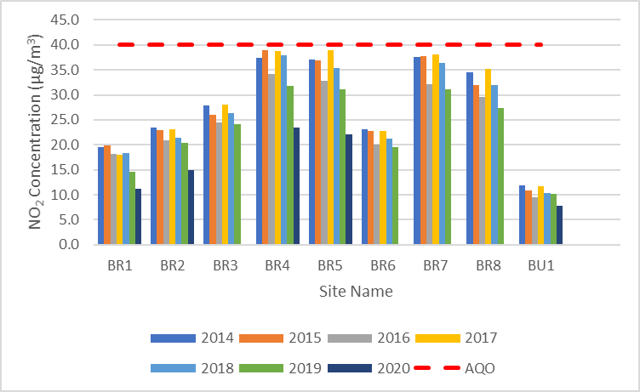

Figure A.2 – Trends in Annual Mean NO2 Concentrations at Other East Hampshire District Council Monitoring Sites

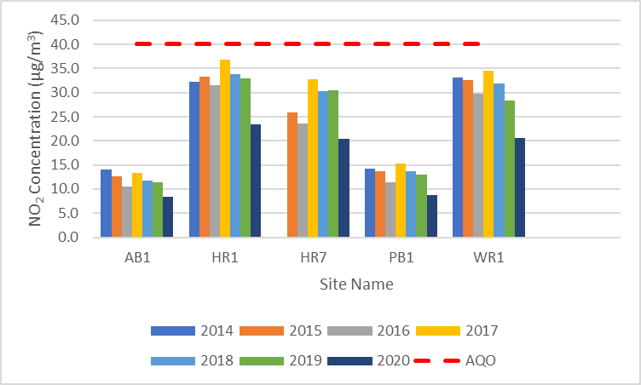

# Appendix B: Full Monthly Diffusion Tube Results

Table B.1 – NO2 2019 Diffusion Tube Results (µg/m3)

| DT ID | X OS Grid Ref (Easting) | Y OS Grid Ref (Easting) | Jan | Feb | Mar | Apr | May | Jun | Jul | Aug | Sep | Oct | Nov | Dec | Annual Mean: Raw Data | Annual Mean: Annualised and Bias Adjusted (0.89) | Annual Mean: Distance Corrected to Nearest Exposure | Comment |
| --- | --- | --- | --- | --- | --- | --- | --- | --- | --- | --- | --- | --- | --- | --- | --- | --- | --- | --- |
| AB1 | 472109 | 139487 | 15.5 | 17.7 | 13.7 | 13.4 | 9.8 | 9.5 | 8.6 | 8.9 | 11.8 | 13.4 | 18.6 | 13.5 | 12.9 | 11.4 | **-** | **-** |
| BR1 | 479707 | 135438 | 22.9 | 21.2 | 18.2 | 15.9 | 11.1 | 12.6 | 12.6 | 12.3 | 14.6 | 17.7 | 21.7 | 16.2 | 16.4 | 14.6 | **-** | **-** |
| BR2 | 479695 | 135356 | 24.5 | 28.6 | 22.4 | 23.9 | 22.5 | 20.7 | 19.7 | 18.2 | 20.8 | 23.3 | 29.9 | 19.5 | 22.8 | 20.3 | **-** | **-** |
| BR3 | 479711 | 135321 | 38.5 | 31.9 | 28.0 | 29.3 | 24.3 | 19.5 | 21.6 | 20.0 | - | 26.9 | 35.0 | 22.8 | 27.1 | 24.1 | **-** | **-** |
| BR4 | 479666 | 135345 | 41.4 | 45.2 | 38.0 | 34.0 | 32.6 | 30.5 | 35.0 | 27.0 | - | 34.3 | 41.5 | 32.8 | 35.7 | 31.7 | **-** | **-** |
| BR5 | 479654 | 135312 | 40.3 | 41.2 | 33.7 | 44.0 | 33.0 | 30.1 | 29.4 | 24.6 | 28.1 | 23.1 | 49.3 | 43.0 | 35.0 | 31.1 | **-** | **-** |
| BR6 | 479646 | 135341 | 25.8 | 29.9 | 19.6 | 23.8 | 17.4 | 20.0 | 17.4 | 17.1 | 19.4 | 23.2 | 28.1 | 20.8 | 21.9 | 19.5 | **-** | **-** |
| BR7 | 479666 | 135345 | 42.8 | 44.4 | 31.2 | 32.7 | 34.0 | 30.5 | 29.5 | 29.7 | - | 35.1 | 43.4 | 30.9 | 34.9 | 31.1 | **-** | **-** |
| BR8 | 479654 | 135312 | 38.1 | 36.0 | 30.4 | 39.7 | 32.5 | 26.1 | 25.5 | 18.6 | 28.5 | 28.1 | 40.8 | 25.5 | 30.8 | 27.4 | **-** | **-** |
| BU1 | 479795 | 136267 | 17.5 | 17.1 | 10.5 | 15.2 | 7.8 | 8.1 | 7.7 | 5.1 | 10.0 | 11.2 | 16.4 | 10.9 | 11.5 | 10.2 | **-** | **-** |
| HR1 | 470554 | 113582 | 49.6 | 51.6 | 38.0 | 31.1 | 32.1 | 30.4 | 30.7 | 31.7 | 33.7 | 36.6 | 42.9 | 35.6 | 37.0 | 32.9 | **-** | **-** |
| HR7 | 470665 | 113259 | 44.9 | 49.2 | 33.1 | 33.0 | 30.7 | 28.6 | 30.4 | 26.7 | 30.2 | 38.5 | 41.1 | 25.2 | 34.3 | 30.5 | **-** | **-** |
| PB1 | 474989 | 123241 | 20.3 | 20.1 | 14.5 | 16.1 | 11.6 | 11.4 | 10.3 | 9.5 | 12.7 | 14.2 | 19.8 | 13.6 | 14.5 | 12.9 | **-** | **-** |
| WR1 | 479314 | 134307 | 37.7 | 39.3 | 33.5 | 35.0 | 30.5 | 27.9 | 28.5 | 24.2 | 29.8 | 32.9 | 36.6 | 25.7 | 31.8 | 28.3 | **-** | **-** |

**All erroneous data has been removed from the NO2 diffusion tube dataset presented in Table B.1.**

**Annualisation has been conducted where data capture is <75% and >25% in line with LAQM.TG16.**

**Local bias adjustment factor used.**

**National bias adjustment factor used.**

**Where applicable, data has been distance corrected for relevant exposure in the final column.**

**East Hampshire District Council confirm that all 2019 diffusion tube data has been uploaded to the Diffusion Tube Data Entry System.**

**Notes:**

Exceedances of the NO2 annual mean objective of 40µg/m3 are shown in **bold**.

NO2 annual means exceeding 60µg/m3, indicating a potential exceedance of the NO2 1-hour mean objective are shown in **bold and underlined**.

See Appendix C for details on bias adjustment and annualisation.

Sites BR4, BR7 and BR5, BR8 are duplicate sites, but are reported separately as the monitoring is undertaken at different heights.

Table B.2 – NO2 2020 Diffusion Tube Results (µg/m3)

| DT ID | X OS Grid Ref (Easting) | Y OS Grid Ref (Easting) | Jan | Feb | Mar | Apr | May | Jun | Jul | Aug | Sep | Oct | Nov | Dec | Annual Mean: Raw Data | Annual Mean: Annualised and Bias Adjusted (0.82) | Annual Mean: Distance Corrected to Nearest Exposure | Comment |
| --- | --- | --- | --- | --- | --- | --- | --- | --- | --- | --- | --- | --- | --- | --- | --- | --- | --- | --- |
| AB1 | 472109 | 139487 | 14.3 | - | 11.3 | 8.4 | - | 6.5 | 7.3 | 7.9 | 10.8 | 9.4 | 16.6 | 14.6 | 10.3 | 8.5 | - | - |
| BR1 | 479707 | 135438 | 21.1 | 16.6 | 14.2 | 11.2 | - | 9.4 | 10.5 | - | - | - | - | - | 13.2 | 11.1 | - | - |
| BR2 | 479695 | 135356 | 23.3 | 18.9 | 18.2 | 14.5 | - | 15.0 | 14.9 | 17.2 | 20.5 | 18.6 | 23.0 | 20.0 | 18.2 | 14.9 | - | - |
| BR4 | 479666 | 135345 | - | 29.2 | 29.4 | 22.9 | - | 23.9 | 24.7 | 28.8 | 32.7 | 29.3 | 37.4 | 33.9 | 28.7 | 23.5 | - | - |
| BR5 | 479654 | 135312 | 50.5 |  | 27.4 | 27.6 | - | 23.8 | 19.7 | 24.2 | 28.6 | 29.7 | 34.1 | 9.7 | 26.9 | 22.0 | - | - |
| BR7 | 479666 | 135345 | 36.4 | 24.3 | - | - | - | - | - | - | - | - | - | - | - | - | - | - |
| BR8 | 479654 | 135312 | 31.3 | - | 23.5 |  | - | - | - | - | - | - | - | - | - | - | - | - |
| BU1 | 479795 | 136267 | - | 9.6 | 10.0 | 8.6 | - | 6.5 | 5.9 | 7.3 | 10.2 | 10.1 | 17.5 | 12.0 | 9.5 | 7.8 | - | - |
| HR1 | 470554 | 113582 | 45.2 | 31.8 | 24.1 | 18.3 | - | 21.7 | 22.2 | 25.5 | 30.6 | 30.6 | 35.6 | 36.4 | 28.5 | 23.3 | - | - |
| HR7 | 470665 | 113259 | 37.4 | 27.0 | 22.6 | 21.5 | - | 22.4 | 19.1 | 25.2 | 27.3 | 24.8 | - | - | 24.9 | 20.4 | - | - |
| PB1 | 474989 | 123241 | 15.9 | 11.6 | 10.5 | 8.4 | - | 6.1 | 7.7 | 9.9 | 11.1 | 9.9 | 16.7 | 13.5 | 10.6 | 8.7 | - | - |
| WR1 | 479314 | 134307 | 35.0 | 24.6 | 28.1 | 20.0 | - | 20.3 | 17.9 | 25.0 | 25.4 | 24.2 | 30.8 | 29.6 | 25.0 | 20.5 | - | - |
| FR1 | 467554 | 135462 | 16.3 | 9.9 | 13.7 | 10.6 | - | - | 8.1 | 11.6 | 13.7 | 12.2 | 17.6 | 13.3 | 12.6 | 10.3 | - | - |
| FR2 | 466586 | 134855 | 16.0 | - | 12.1 | 8.9 | - | - | - | - | - | - | 17.4 | 15.0 | 13.5 | 8.8 | - | - |

**All erroneous data has been removed from the NO2 diffusion tube dataset presented in Table B.1.**

**Annualisation has been conducted where data capture is <75% and >25% in line with LAQM.TG16.**

**Local bias adjustment factor used.**

**National bias adjustment factor used.**

**Where applicable, data has been distance corrected for relevant exposure in the final column.**

**East Hampshire District Council confirm that all 2020 diffusion tube data has been uploaded to the Diffusion Tube Data Entry System.**

**Notes:**

Exceedances of the NO2 annual mean objective of 40µg/m3 are shown in **bold**.

NO2 annual means exceeding 60µg/m3, indicating a potential exceedance of the NO2 1-hour mean objective are shown in **bold and underlined**.

See Appendix C for details on bias adjustment and annualisation.

# Appendix C: Supporting Technical Information / Air Quality Monitoring Data QA/QC

## New or Changed Sources Identified Within East Hampshire District Council During 2019 and 2020

East Hampshire District Council has not identified any new sources relating to air quality within the reporting years of 2019 and 2020.

## Additional Air Quality Works Undertaken by East Hampshire District Council During 2019 and 2020

East Hampshire District Council has not completed any additional works within the reporting years of 2019 and 2020.

## QA/QC of Diffusion Tube Monitoring

East Hampshire District Council’s NO2 diffusion tubes are supplied and analysed by Gradko International Ltd using the 50% TEA in Acetone method. This method conforms to the guidelines set out in Defra’s ‘Diffusion Tubes for Ambient NO2 Monitoring: Practical Guidance’ document.

Gradko International participates in the AIR NO2 PT scheme. This scheme forms an integral part of the UK NO2 Network’s QA/QC and is a useful tool in assessing the analytical performance of those laboratories supplying diffusion tubes to Local Authorities for use in the context of Local Air Quality Management (LAQM). In AIR NO2 PT rounds AR040 (September – October 2020) and AR036 (January – February 2020) Gradko achieved 75% satisfactory scores. In prior AIR NO2 PT rounds AR034, AR033, AR031 and AR030 (covering periods from January to November 2019) Gradko achieved 100% satisfactory scores.

Diffusion tubes in 2019 were deployed in adherence to the Defra Diffusion Tube Monitoring Calendar. However, in 2020 deployment deviated from the Diffusion Tube Monitoring Calendar. No diffusion tubes were installed in May, with extended exposure periods for April and June as a result. A time-weighted average was calculated to account for this.

### Diffusion Tube Annualisation

If annualisation was required for any non-automatic monitoring sites, the sites requiring annualisation should be clearly defined along with details of the calculation method undertaken provided in Table C.2. Annualisation is required for any site with data capture less than 75% but greater than 25%.

All diffusion tube monitoring locations within East Hampshire District Council recorded data capture of 75% in 2019 therefore it was not required to annualise any monitoring data.

Two sites in 2020 recorded a data capture of less than 75%: BR1 and FR2. Annualisation was performed utilising three Defra AURN continuous background monitors within a 50-mile radius, these are Chilbolton Observatory, Reading New Town and Eastleigh-Steele Close. A fourth monitor at Portsmouth was not used as data capture was below the recommended 85%. In addition, any sites with a data capture below 25% do not require annualisation.

### Diffusion Tube Bias Adjustment Factors

The diffusion tube data presented within the 2020 and 2021 ASR have been corrected for bias using an adjustment factor. Bias represents the overall tendency of the diffusion tubes to under or over-read relative to the reference chemiluminescence analyser. LAQM.TG16 provides guidance with regard to the application of a bias adjustment factor to correct diffusion tube monitoring. Triplicate co-location studies can be used to determine a local bias factor based on the comparison of diffusion tube results with data taken from NOx/NO2 continuous analysers. Alternatively, the national database of diffusion tube co-location surveys provides bias factors for the relevant laboratory and preparation method.

East Hampshire District Council do not have a co-location study, and thus have applied a national bias adjustment factor of 0.89 and 0.82 to the 2019 and 2020 monitoring data respectively. A summary of bias adjustment factors used by East Hampshire District Council over the past five years is presented in Table C.1. Version 03/21 of the Defra Diffusion Tube Bias Adjustment Factors Spreadsheet was used for both 2019 and 2020 bias adjustment factors.

Table C.1 – Bias Adjustment Factor

| Year | Local or National | If National, Version of National Spreadsheet | Adjustment Factor |
| --- | --- | --- | --- |
| **2020** | National | 03/21 | 0.82 |
| **2019** | National | 03/21 | 0.89 |
| **2018** | National | 06/19 | 0.89 |

### NO2 Fall-off with Distance from the Road

Wherever possible, local authorities should ensure that monitoring locations are representative of exposure. However, where this is not possible, the NO2 concentration at the nearest location relevant for exposure should be estimated using the Diffusion Tube Data Processing Tool/NO2 fall-off with distance calculator available on the LAQM Support website. Where appropriate, non-automatic annual mean NO2 concentrations corrected for distance are presented in Table B.1.

No diffusion tube NO2 monitoring locations within East Hampshire District Council required distance correction during 2019 or 2020.

Table C.2 – 2020 Annualisation Summary (concentrations presented in µg/m3)

| Site ID | Annualisation Factor Chilbolton Observatory | Annualisation Factor Portsmouth | Annualisation Factor Reading New Town | Annualisation Factor Eastleigh-Steele Close | Average Annualisation Factor | Raw Data Annual Mean | Annualised Raw Annual Mean | Comments |
| --- | --- | --- | --- | --- | --- | --- | --- | --- |
| BR1 | 1.0332 |  | 1.0360 | 1.0202 | 1.0298 | 13.2 | 13.6 |  |
| FR2 | 0.7857 |  | 0.8065 | 0.7906 | 0.7943 | 13.5 | 10.7 |  |

# Appendix D: Map(s) of Monitoring Locations and AQMAs

Figure D.1 – Map of Non-Automatic Monitoring Sites in Bordon

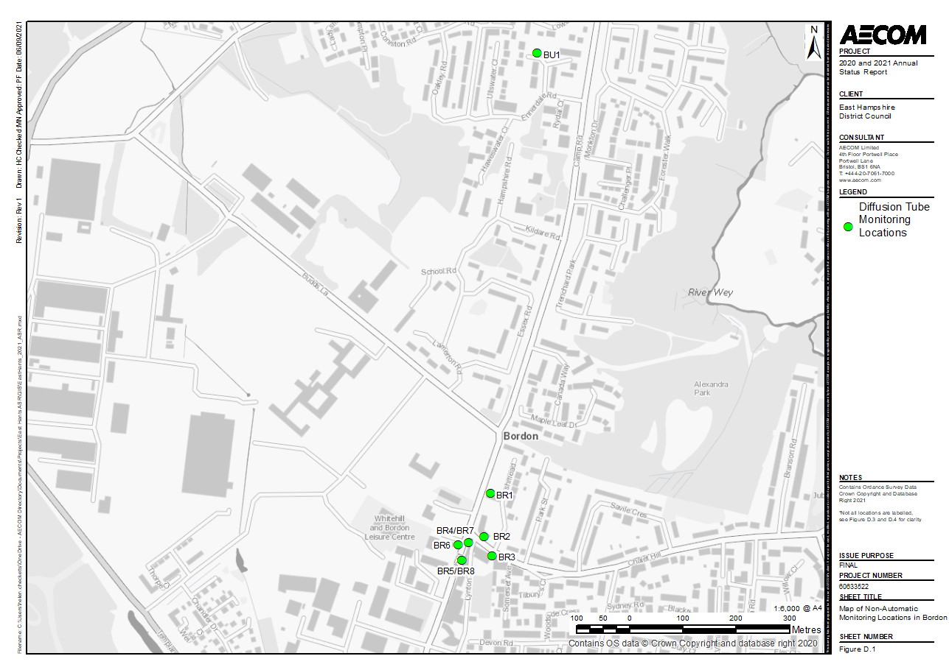

Figure D.2 – Map of Non-Automatic Monitoring Sites in Whitehill

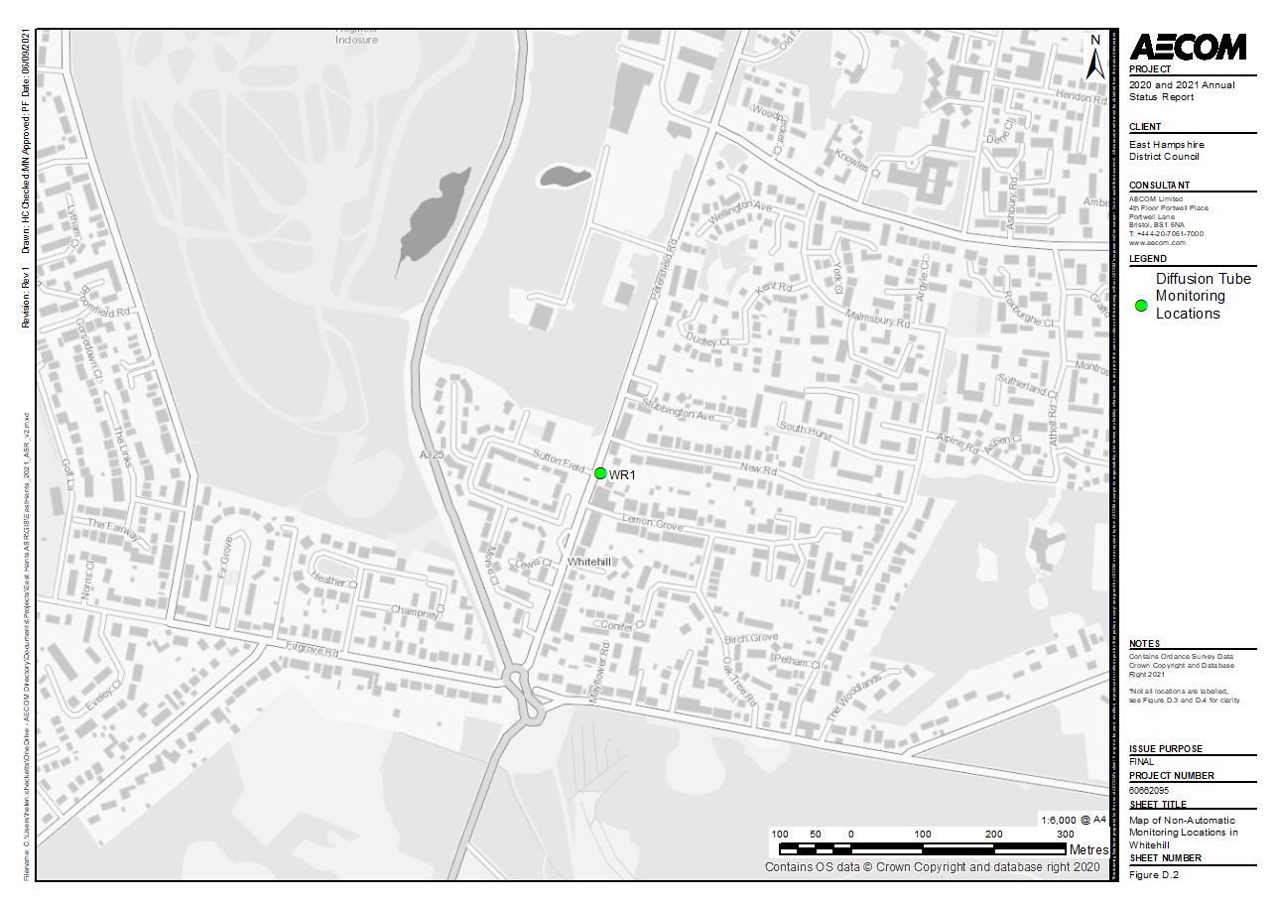

Figure D.3 – Map of Non-Automatic Monitoring Sites in Alton

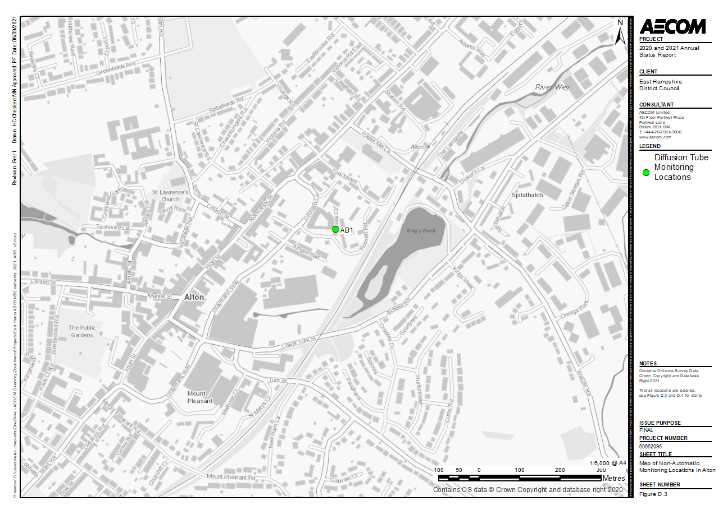

Figure D.4 – Map of Non-Automatic Monitoring Sites in Four Marks

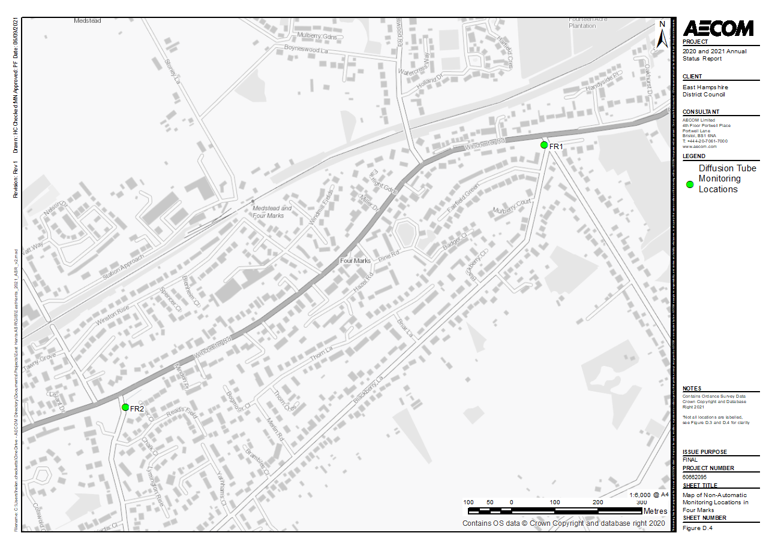

Figure D.5 – Map of Non-Automatic Monitoring Sites in Petersfield

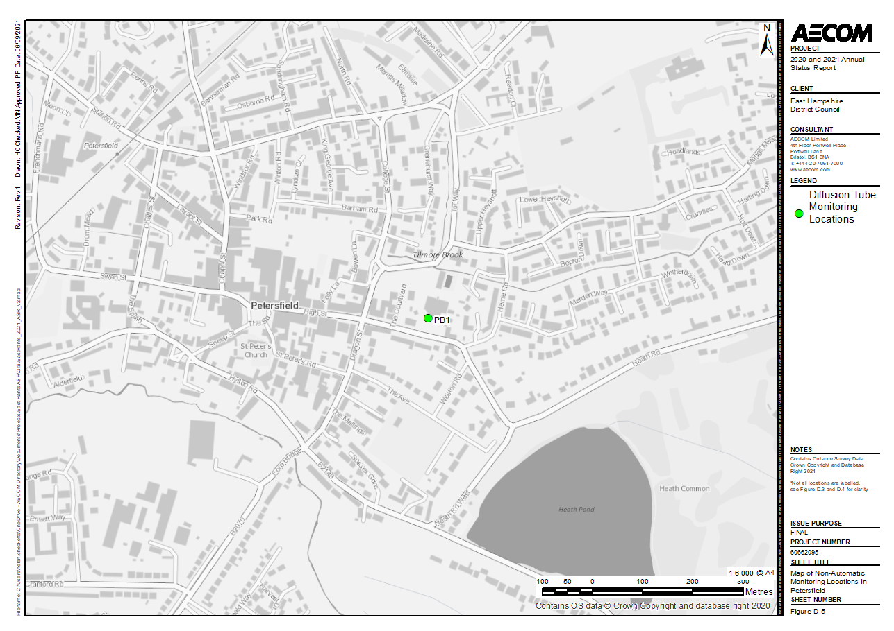

Figure D.6 – Map of Non-Automatic Monitoring Sites in Horndean

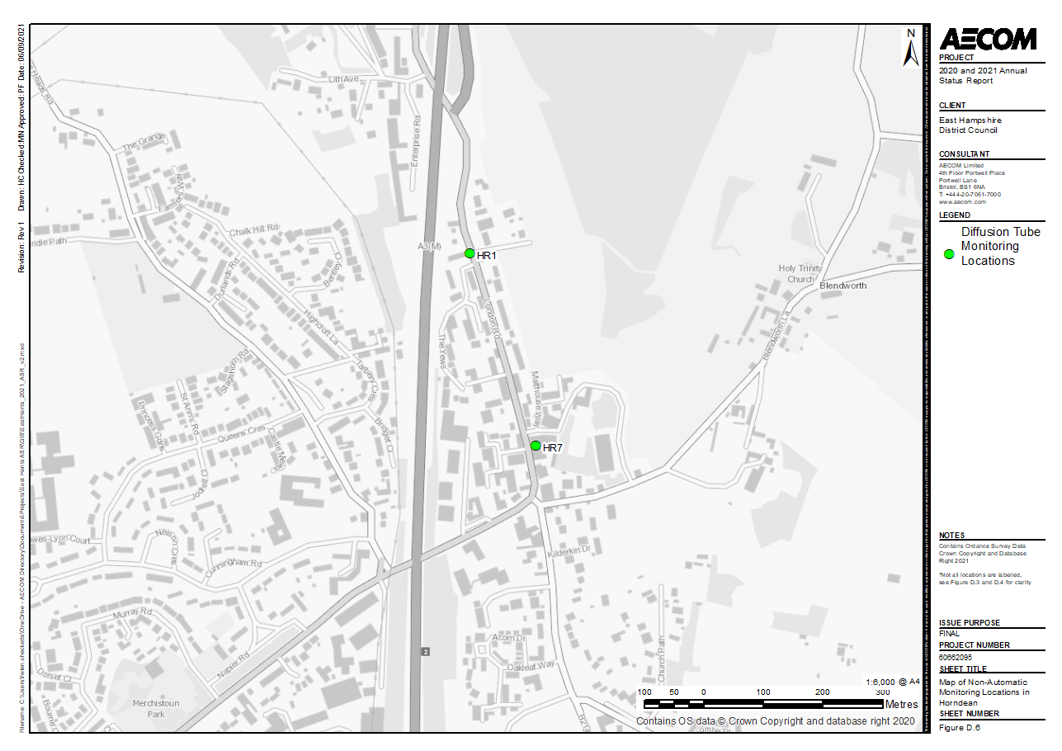

# Appendix E: Summary of Air Quality Objectives in England

Table E.1 – Air Quality Objectives in England[8]

| Pollutant | Air Quality Objective: Concentration | Air Quality Objective: Measured as |
| --- | --- | --- |
| Nitrogen Dioxide (NO2) | 200µg/m3 not to be exceeded more than 18 times a year | 1-hour mean |
| Nitrogen Dioxide (NO2) | 40µg/m3 | Annual mean |
| Particulate Matter (PM10) | 50µg/m3, not to be exceeded more than 35 times a year | 24-hour mean |
| Particulate Matter (PM10) | 40µg/m3 | Annual mean |
| Sulphur Dioxide (SO2) | 350µg/m3, not to be exceeded more than 24 times a year | 1-hour mean |
| Sulphur Dioxide (SO2) | 125µg/m3, not to be exceeded more than 3 times a year | 24-hour mean |
| Sulphur Dioxide (SO2) | 266µg/m3, not to be exceeded more than 35 times a year | 15-minute mean |

# Appendix F: Impact of COVID-19 upon LAQM

COVID-19 has had a significant impact on society. Inevitably, COVID-19 has also had an impact on the environment, with implications to air quality at local, regional and national scales.

COVID-19 has presented various challenges for Local Authorities with respect to undertaking their statutory LAQM duties in the 2021 reporting year. Recognising this, Defra provided various advice updates throughout 2020 to English authorities, particularly concerning the potential disruption to air quality monitoring programmes, implementation of Air Quality Action Plans (AQAPs) and LAQM statutory reporting requirements. Defra has also issued supplementary guidance for LAQM reporting in 2021 to assist local authorities in preparing their 2021 ASR. Where applicable, this advice has been followed.

Despite the challenges that the pandemic has given rise to, the events of 2020 have also provided Local Authorities with an opportunity to quantify the air quality impacts associated with wide-scale and extreme intervention, most notably in relation to emissions of air pollutants arising from road traffic. The vast majority (>95%) of AQMAs declared within the UK are related to road traffic emissions, where attainment of the annual mean objective for nitrogen dioxide (NO2) is considered unlikely. On 23rd March 2020, the UK Government released official guidance advising all members of public to stay at home, with work-related travel only permitted when absolutely necessary. During this initial national lockdown (and to a lesser extent other national and regional lockdowns that followed), marked reductions in vehicle traffic were observed; Department for Transport (DfT) data[9] suggests reductions in vehicle traffic of up to 70% were experienced across the UK by mid-April, relative to pre COVID-19 levels.

This reduction in travel in turn gave rise to a change of air pollutant emissions associated with road traffic, i.e. nitrous oxides (NOx), and exhaust and non-exhaust particulates (PM). The Air Quality Expert Group (AQEG)[10] has estimated that during the initial lockdown period in 2020, within urbanised areas of the UK reductions in NO2 annual mean concentrations were between 20 and 30% relative to pre-pandemic levels, which represents an absolute reduction of between 10 to 20µg/m3 if expressed relative to annual mean averages. During this period, changes in PM2.5 concentrations were less marked than those of NO2. PM2.5 concentrations are affected by both local sources and the transport of pollution from wider regions, often from well beyond the UK. Through analysis of AURN monitoring data for 2018-2020, AQEG have detailed that PM2.5 concentrations during the initial lockdown period are of the order 2 to 5µg/m3 lower relative to those that would be expected under business-as-usual conditions.

As restrictions are gradually lifted, the challenge is to understand how these air quality improvements can benefit the long-term health of the population.

## Impacts of COVID-19 on Air Quality within East Hampshire District Council

All monitoring locations across East Hampshire showed a decrease in annual mean NO2 concentrations between 2019 to 2020. Whilst this is a continuation of wider trends in recent years, the drastic reduction is likely to have arisen as a consequence of COVID-19. The percentage reduction in annual mean concentration between 2019 and 2020 ranged from 23.8% to 33.3%, with an average reduction across all sites of 27.8%.

## Opportunities Presented by COVID-19 upon LAQM within East Hampshire District Council

No LAQM related opportunities have arisen as a consequence of COVID-19 within East Hampshire District Council.

## Challenges and Constraints Imposed by COVID-19 upon LAQM within East Hampshire District Council

The primary challenge or constraint relating to LAQM arising during 2020 as a consequence of COVID-19 within East Hampshire District Council was the ability to adhere to the Defra Diffusion Tube Calendar during the national lockdown in Spring 2020. This affected the Council’s ability to carry out changeovers. In addition, the closure of the laboratory caused disturbances to the analysis and supply of the diffusion tubes. Ultimately, most monitoring locations had a data capture of greater than 75%. The impact can be classified as **small to none** as per the Impact Matrix in Table F.1.

Table F – Impact Matrix

| Category | Impact Rating: None | Impact Rating: Small | Impact Rating: Medium | Impact Rating: Large |
| --- | --- | --- | --- | --- |
| Automatic Monitoring – Data Capture (%) | More than 75% data capture | 50 to 75% data capture | 25 to 50% data capture | Less than 25% data capture |
| Automatic Monitoring – QA/QC Regime | Adherence to requirements as defined in LAQM.TG16 | Routine calibrations taken place frequently but not to normal regime. Audits undertaken alongside service and maintenance programmes | Routine calibrations taken place infrequently and service and maintenance regimes adhered to. No audit achieved | Routine calibrations not undertaken within extended period (e.g. 3 to 4 months). Interruption to service and maintenance regime and no audit achieved |
| Passive Monitoring – Data Capture (%) | More than 75% data capture | 50 to 75% data capture | 25 to 50% data capture | Less than 25% data capture |
| Passive Monitoring – Bias Adjustment Factor | Bias adjustment undertaken as normal | <25% impact on normal number of available bias adjustment colocation studies (2020 vs 2019) | 25-50% impact on normal number of available bias adjustment studies (2020 vs 2019) | >50% impact on normal number of available bias adjustment studies (2020 vs 2019) and/or applied bias adjustment factor studies not considered representative of local regime |
| Passive Monitoring – Adherence to Changeover Dates | Defra diffusion tube exposure calendar adhered to | Tubes left out for two exposure periods | Tubes left out for three exposure periods | Tubes left out for more than three exposure periods |
| Passive Monitoring – Storage of Tubes | Tubes stored in accordance with laboratory guidance and analysed promptly. | Tubes stored for longer than normal but adhering to laboratory guidance | Tubes unable to be stored according to be laboratory guidance but analysed prior to expiry date | Tubes stored for so long that they were unable to be analysed prior to expiry date. Data unable to be used |
| AQAP – Measure Implementation | Unaffected | Short delay (<6 months) in development of a new AQAP, but is on-going | Long delay (>6 months) in development of a new AQAP, but is on-going | No progression in development of a new AQAP |
| AQAP – New AQAP Development | Unaffected | Short delay (<6 months) in development of a new AQAP, but is on-going | Long delay (>6 months) in development of a new AQAP, but is on-going | No progression in development of a new AQAP |

# Glossary of Terms

| Abbreviation | Description |
| --- | --- |
| AQAP | Air Quality Action Plan - A detailed description of measures, outcomes, achievement dates and implementation methods, showing how the local authority intends to achieve air quality limit values’ |
| AQEG | Air Quality Expert Group |
| AQMA | Air Quality Management Area – An area where air pollutant concentrations exceed / are likely to exceed the relevant air quality objectives. AQMAs are declared for specific pollutants and objectives |
| ASR | Annual Status Report |
| Defra | Department for Environment, Food and Rural Affairs |
| DfT | Department for Transport |
| DMRB | Design Manual for Roads and Bridges – Air quality screening tool produced by Highways England |
| EU | European Union |
| FDMS | Filter Dynamics Measurement System |
| LAQM | Local Air Quality Management |
| MOVA | Microprocessor Optimised Vehicle Actuation |
| NO2 | Nitrogen Dioxide |
| NOx | Nitrogen Oxides |
| PM10 | Airborne particulate matter with an aerodynamic diameter of 10µm or less |
| PM2.5 | Airborne particulate matter with an aerodynamic diameter of 2.5µm or less |
| QA/QC | Quality Assurance and Quality Control |
| SO2 | Sulphur Dioxide |

# References

* Local Air Quality Management Technical Guidance LAQM.TG16. April 2021. Published by Defra in partnership with the Scottish Government, Welsh Assembly Government and Department of the Environment Northern Ireland.
* Local Air Quality Management Policy Guidance LAQM.PG16. May 2016. Published by Defra in partnership with the Scottish Government, Welsh Assembly Government and Department of the Environment Northern Ireland.
* Public Health England. Air Quality: A Briefing for Directors of Public Health, 2017
* Defra. Air quality and social deprivation in the UK: an environmental inequalities analysis, 2006
* Defra. Air quality appraisal: damage cost guidance, July 2020
* Public Health England. Estimation of costs to the NHS and social care due to the health impacts of air pollution: summary report, May 2018
* Defra. Clean Air Strategy, 2019
* DfT. The Road to Zero: Next steps towards cleaner road transport and delivering our Industrial Strategy, July 2018
* East Hampshire District Council. Climate and Environment Strategy 2020-2025, August 2020.
* Prime Minister’s Office, COVID-19 briefing on the 31st of May 2020
* Air Quality Expert Group, Estimation of changes in air pollution emissions, concentrations and exposure during the COVID-19 outbreak in the UK, June 2020
* Public Health England. Public Health Outcomes Framework. August 2021.

1. Public Health England. Air Quality: A Briefing for Directors of Public Health, 2017
2. Defra. Air quality and social deprivation in the UK: an environmental inequalities analysis, 2006
3. Defra. Air quality appraisal: damage cost guidance, July 2020
4. Public Health England. Estimation of costs to the NHS and social care due to the health impacts of air pollution: summary report, May 2018
5. Defra. Clean Air Strategy, 2019
6. DfT. The Road to Zero: Next steps towards cleaner road transport and delivering our Industrial Strategy, July 2018
7. East Hampshire District Council. Climate and Environment Strategy 2020-2025, August 2020.
8. The units are in microgrammes of pollutant per cubic metre of air (µg/m3).
9. Prime Minister’s Office, COVID-19 briefing on the 31st of May 2020
10. Air Quality Expert Group, Estimation of changes in air pollution emissions, concentrations and exposure during the COVID-19 outbreak in the UK, June 2020