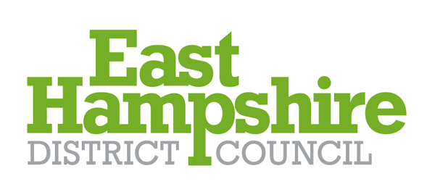
BIODIVERSITY NET GAIN – The Council’s Position Statement Nov 2023

What is Biodiversity Net Gain?
Biodiversity Net Gain (BNG) is an approach to development which leaves biodiversity in a better state than before. Achieving BNG means that natural habitats will be extended or improved as part of a development or project. Development will be designed in a way that provides benefits to people and nature and reduces its impact on the wider environment.
In all cases, BNG should seek to bolster the local ecological network by providing habitat that is relevant to the area and which will complement the existing habitat mix.
Legislative Framework
The Environment Act 2021 includes provisions that make the achievement of a minimum 10% biodiversity gain mandatory for developments under the Town and Country Planning Act 1990. Mandatory BNG is due to come into force in early 2024.
In national policy context, the National Planning Policy Framework (NPPF), Paragraph 180, refers to securing measurable net gains for biodiversity. Paragraphs 22 to 27 of the National Planning Practice Guidance (NPPG) on the Natural Environment provides further information and guidance on BNG.
The East Hampshire Joint Core Strategy, Policy CP21 ‘Biodiversity’ (d) states that “new development will be required to ensure wildlife enhancements are incorporated into the design to achieve a net gain in biodiversity………”.
Including BNG in Plans and Projects
Early consideration of BNG in your plans and projects will be key to meeting the new mandatory requirement. The Council, developers and landowners each have a role to play in ensuring BNG is achieved:
- East Hampshire District Council
As a Hampshire local authority, East Hampshire District Council is a member of the Hampshire led BNG Steering Group. The group meets up regularly to discuss and implement the Government’s aim of mandatory BNG (mandatory from early 2024) and it provides the opportunity to talk to others, including local wildlife groups and nature partnerships and work collectively to define what the priorities are for biodiversity in Hampshire. We are considering how this fits longer term with bigger, more joined up ambitions for nature’s recovery.
The Council is also thinking about how biodiversity net gain fits in with our existing plan, strategies and proposed local plan allocations. BNG can complement our wider biodiversity objectives, whether creating new green infrastructure or improving climate resilience.
- Developers
As a developer, it is best to start thinking about how BNG fits with your projects as early as possible; evidence shows that the earlier projects start to think about BNG, the easier you will find it to deliver alongside your other requirements and ambitions. Further information and guidance for developers can be found here:
Meet biodiversity net gain requirements: steps for developers - GOV.UK (www.gov.uk)
- Landowners
As a landowner there is the opportunity to offer your land as potential biodiversity net gain sites where options for off-site (from a development site) BNG are required. Work to calculate and establish the baseline value of such sites will be required but starting work early can lead to more than doubling of the number of units available for sale within just a few years. Further information and guidance for land managers can be found here:
Meet your BNG requirements: steps to take for land managers - GOV.UK (www.gov.uk)
Further Guidance
- Natural England’s Biodiversity Metric
To assist, Natural England has produced a tool call the Biodiversity Metric. This metric is an excel spreadsheet which uses information about habitats as a proxy measure for biodiversity. Information is entered about the habitats present. The metric then translates this information into a score which is presented in biodiversity units. The information needed is taken from habitat surveys/assessment of the site. Information on each habitat type present prior to development (at the time of application, taking into account any deliberate harm to biodiversity in the recent past) is entered to form the baseline. Then the proposed post development habitat information is entered. If off-site BNG is proposed, the baseline and post-development scores for the offsetting site are also entered. To meet BNG requirements a development must have a sufficiently higher biodiversity unit score after development than before development. Irreplaceable habitats are excluded from the metric because their protection and enhancement is covered by other policy requirements.
Further information on the Biodiversity metric tool and other aspects of Biodiversity Net Gain can be found on the Government’s website and can be accessed via the link below:
Biodiversity net gain - GOV.UK (www.gov.uk)

See further guidance set out in the ‘East Hampshire District Council Biodiversity and Planning Guidance’ June 2021

