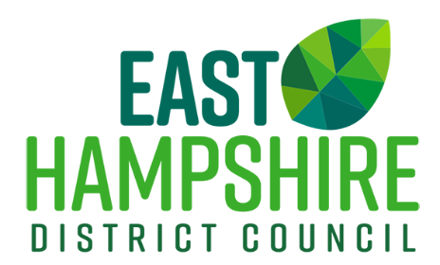 | Enquiries to:  Direct Dial:  Email:  Web: | Licensing  01730 234379/89/99  licensing@easthants.gov.uk  www.easthants.gov.uk

Become a Licensed Taxi/Private Hire Driver with East Hampshire District Council

- Application form to be licensed as a Hackney/Private Hire Driver
  - Please complete the application form for a new Hackney Carriage/Private Hire Driver Licence and send it to licensing@easthants.gov.uk. Once received you will be contacted by telephone to take payment for your application.
  - You will be interviewed by an officer who will contact you to arrange a suitable date and time.

- Driving Licence
  - You must have held a driving licence for a minimum of three years at the time you apply. A copy of your driving licence will be required.

- DVLA Driver Licence Check
  - Please provide a printout of your driving licence ‘check code’ by going online to gov.uk and searching for ‘share my driving licence details’ (https://www.gov.uk/view-driving-licence) the code lasts for 21 days.

- Immigration Act 2016
  - All applicants for the grant of a dual hackney carriage/private hire driver licence must provide evidence of their right to work in the UK. Further details on the Immigration Act together with the list of acceptable documents (List A and List B) are detailed on a separate document.

- DVLA Medical examination report
  - Please make an appointment to have your medical completed by your own GP, or GP within the same practice who has access to your full medical records. Please return your completed medical to this office. We will forward this to our medical advisors who will advise whether you meet the DVLA Group 2 medical standard.

- Online Disclosure and Barring Service (DBS)
  - You are required to have an enhanced DBS, your application for this will be started during your driver interview.

- Knowledge Test Guidance
  - During your interview a knowledge test appointment will be booked.

- Safeguarding Training
  - You must have successfully completed an approved training/awareness raising course in relation to the safeguarding of children and vulnerable people. The course must have been pre-approved by the Licensing Authority.

- Driving Assessment: Information about providers
  - Please contact one of the providers to book a driving assessment. We will be notified by your chosen provider of the result of your assessment.

- Details of the BTEC qualification requirement
  - You will need to obtain this qualification within 12 months of being granted a licence.

- Photograph
  - You will need to provide a current passport size photograph of yourself.

- Fee
  - Details of fees are enclosed. Payment must be made prior to your interview.

We will use the information provided to determine your application. A list of the criteria used to determine an application can be seen in the Council’s Licensing Policy available on our website. Should your application be refused, you will be refunded your initial application fee only. You also have the right of appeal to the Magistrates Court within 21 days.

You may begin your application at any time. You do not need to have completed all the above steps to submit your application.

Please email documents requested to licensing@easthants.gov.uk

